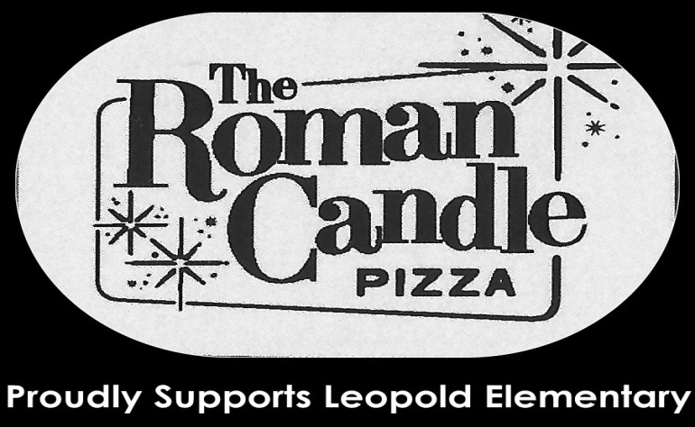
Thursday, October 17, 2013
4 pm- Close

Roman Candle will be donating 10% of all proceeds to Leopold Elementary!

Dine In or Carry Out

2685 Research Park Dr, Fitchburg
278-1111

Leopold Elementary Family Night
Thursday, October 17, 2013
4 pm- Close

Roman Candle will be donating 10% of all proceeds to Leopold Elementary!

Dine In or Carry Out

2685 Research Park Dr, Fitchburg
278-1111
Thursday, October 17, 2013
4 pm- Close

Roman Candle will be donating 10% of all proceeds to Leopold Elementary!

Dine In or Carry Out

2685 Research Park Dr, Fitchburg
278-1111

Leopold Elementary Family Night
Thursday, October 17, 2013
4 pm- Close

Roman Candle will be donating 10% of all proceeds to Leopold Elementary!

Dine In or Carry Out

2685 Research Park Dr, Fitchburg
278-1111

Jueves, 17 octubre 2013
4 pm-close

Roman Candle donará el 10% de todos los ingresos a Leopold Elementary!

Comer en el restaurante o para llevar a cabo
2685 Research Park Dr, Fitchburg
278-1111

Jueves, 17 de octubre 2013
4 pm-close

Roman Candle donará el 10% de todos los ingresos a Leopold Elementary!

Comer en el restaurante o para llevar a cabo
2685 Research Park Dr, Fitchburg
278-1111

Jueves, 17 de octubre 2013
4 pm-close

Roman Candle donará el 10% de todos los ingresos a Leopold Elementary!

Comer en el restaurante o para llevar a cabo
2685 Research Park Dr, Fitchburg
278-1111

Jueves, 17 de octubre 2013
4 pm-close

Roman Candle donará el 10% de todos los ingresos a Leopold Elementary!

Comer en el restaurante o para llevar a cabo
2685 Research Park Dr, Fitchburg
278-1111

